# System Design Document

By Ryan LeChien

## UML Diagrams

### UML Use Case Diagram

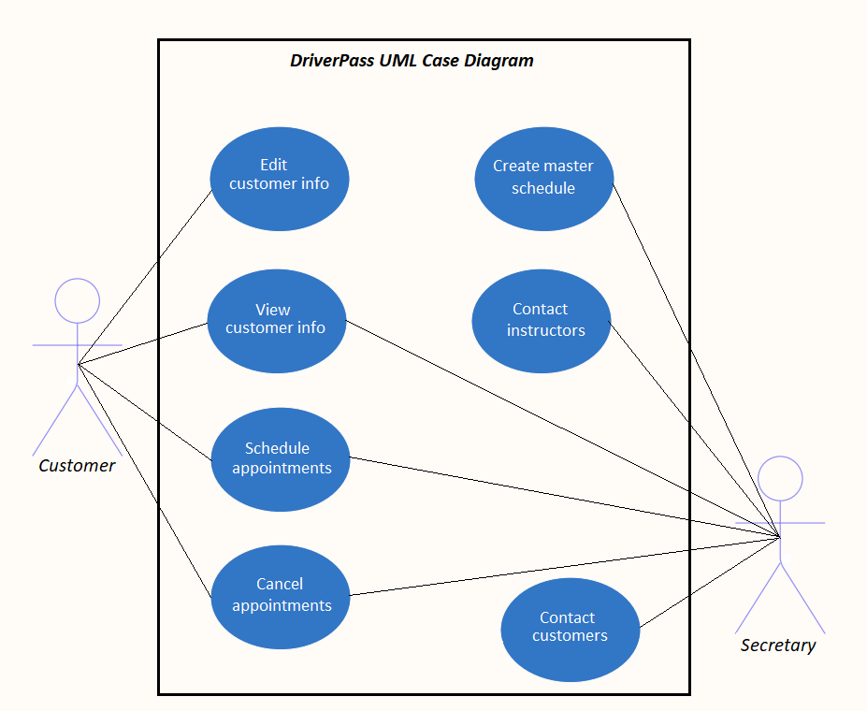

### UML Activity Diagrams

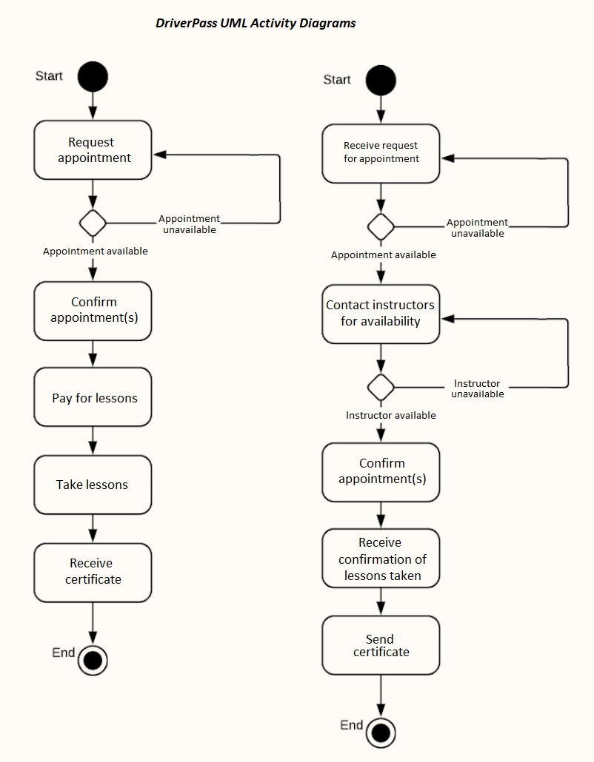

### UML Sequence Diagram

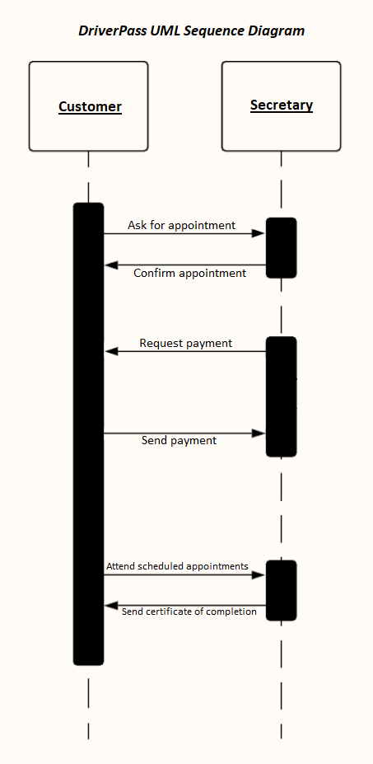

### UML Class Diagram

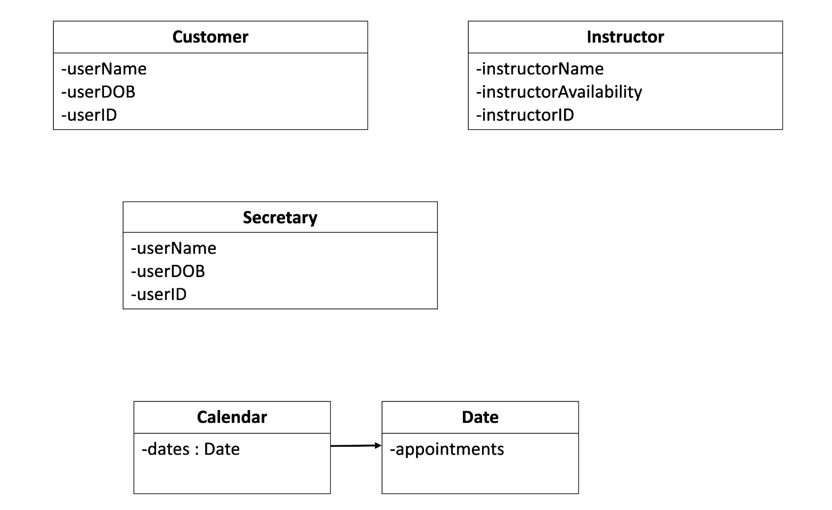

## Technical Requirements

The DriverPass application requires a robust set of technical requirements to ensure its effectiveness and reliability. A responsive front-end framework is crucial to create an intuitive user interface that adapts seamlessly across various devices and screen sizes. An efficient database must be maintained to interface with this front-end. To facilitate seamless scheduling for lessons, external programs for payment should be integrated. Security measures, including data encryption and input validation, should also be implemented.